Differences between HTTP1.1 Vs HTTP2

[HTTP](https://www.cloudflare.com/learning/ddos/glossary/hypertext-transfer-protocol-http/) stands for hypertext transfer protocol. HTTP is the method computers and servers use to request and send information.

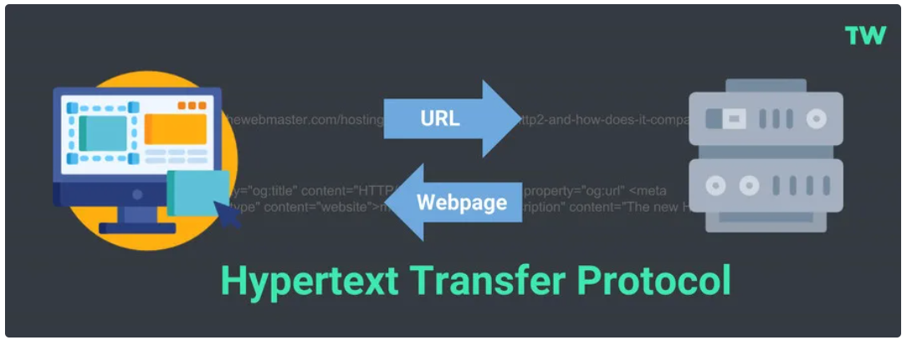

HTTP/1.1, keeps all requests and responses in plain text format, HTTP/2 uses the binary framing layer to encapsulate all messages in binary format, while still maintaining HTTP semantics, such as verbs, methods, and headers.

**Binary framing layer:** At the core of all performance enhancements of HTTP/2 is the new binary framing layer, which dictates how the HTTP messages are encapsulated and transferred between the client and server.

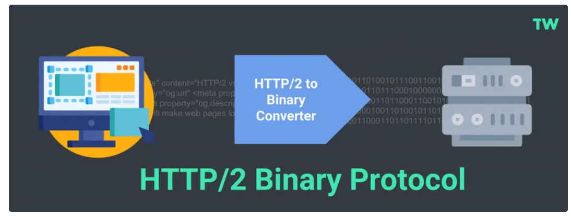

**Multiplexing:** HTTP/1.1 introduced the concept of pipelining to send multiple requests over a single connection in sequence, but HTTP/2 gave us **multiplexing**, which allows browsers to send multiple requests in parallel over a single connection.

“Multiplexing means your browser can send multiple requests and receive multiple responses "bundled" into a single TCP connection. So, the workload associated with DNS lookups and handshakes is saved for files coming from the same server.”

**Server push:** Typically, a server only serves content to a client device if the client asks for it. However, this approach is not always practical for modern webpages, which often involve several dozen separate resources that the client must request. HTTP/2 solves this problem by allowing a server to **"push"** content to a client before the client asks for it. The server also sends a message letting the client know what pushed content to expect – like if Bob had sent Alice a Table of Contents of his novel before sending the whole thing.

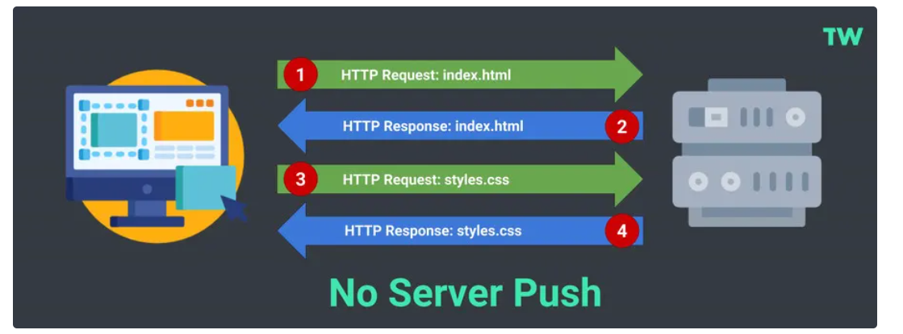

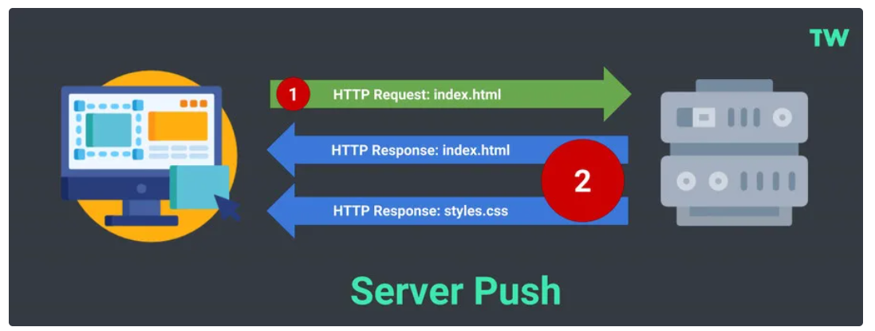

**Header compression:** Small files load more quickly than large ones. To speed up web performance, both HTTP/1.1 and HTTP/2 compress HTTP messages to make them smaller. However, HTTP/2 uses a more advanced compression method called **HPACK** that eliminates redundant information in HTTP header packets. This eliminates a few bytes from every HTTP packet. Given the volume of HTTP packets involved in loading even a single webpage, those bytes add up quickly, resulting in faster loading.

These are the high-level differences between HTTP1 and HTTP2:

* HTTP2 is binary, instead of textual
* HTTP2 is fully multiplexed, instead of ordered and blocking
* HTTP2 can, therefore, use one connection for parallelism
* HTTP2 uses header compression to reduce overhead
* HTTP2 allows servers to “push” responses proactively into client caches